Birds of a Feather Don’t Flock Together:

China’s Foreign Aid Targeting in Relation to Governance Style

Edgar Agunias A69046387
GPCO 454 - Quantitative Methods II
Independent Analysis Project
Professor Ravanilla
March 11th 2026



Acknowledgements

Table of Contents
Birds of a Feather Don’t Flock Together: 1
China’s Foreign Aid Targeting in Relation to Governance Style 1
Acknowledgements 2
Table of Contents 3
Memo 4
Introduction 4
Theory and Hypothesis: 4
Data Description: 4
Methodology and Findings: 6
Limitations and Conclusion: 6

Memo
Date: March 11th 2026
To: Marco Rubio, Secretary of State
From: Edgar Agunias
Regarding: China’ Aid Targeting Strategy

Introduction
With a large US pullback on foreign aid contributions in the UN and elsewhere, many in the international community look to China to fill part of this gap. Many see it as logical for China to expand its influence through aid, yet China has historically been selective in how it allocates development finance. This research asks whether Chinese aid is associated with more authoritarian governments. China’s aid allocation differs from that of the United States, which often channels aid through multilateral institutions, while China relies more heavily on bilateral finance. In Western debates, China’s development finance and Belt and Road lending are often portrayed as politically motivated. Using country-level cross-sectional OLS models, I find a positive bivariate association between autocracy and Chinese aid. After economic and demographic controls are added in the full sample, autocracy is not a statistically significant predictor of mean annual aid. However, among countries that received positive Chinese aid, a one-point increase in autocracy score is associated with roughly 2.95 times higher mean annual aid, holding the included controls constant. These results suggest that regime type does not robustly predict aid across all countries, but it may still matter conditional on being an aid recipient.

Theory and Hypothesis:
Our research question is: are more autocratic regimes associated with higher average Chinese aid?
Null Hypothesis: Autocratic regimes are not associated with different average Chinese aid levels than democratic regimes.
Alternative Hypothesis: More autocratic regimes are associated with higher average Chinese aid levels than more democratic regimes.
$$H_{0}: μ_{Autocratic}=μ_{Democratic} H_{a}: μ_{Autocratic}>μ_{Democratic}$$

Data Description:
Using the Our World in Data (OWID) regime data and the Chinese Global Development Finance data set, I estimate country-level cross-sectional models of Chinese aid allocation. The panel is collapsed into country averages over 2013 to 2021, so the unit of analysis is the country rather than the country-year. The dependent variable is Log(1 + mean annual Chinese aid in constant 2021 USD). The autocracy measure ranges from 0 to 3, where 0 denotes electoral democracies and 3 denotes closed autocracies. The analytic sample includes 174 countries in the bivariate model, 135 countries in the full controls model, and 92 aid-receiving countries in the positive-aid-only robustness model. The country-level descriptive patterns still show that more authoritarian countries receive more aid on average, but the regression results indicate that this relationship depends on the specification and sample.
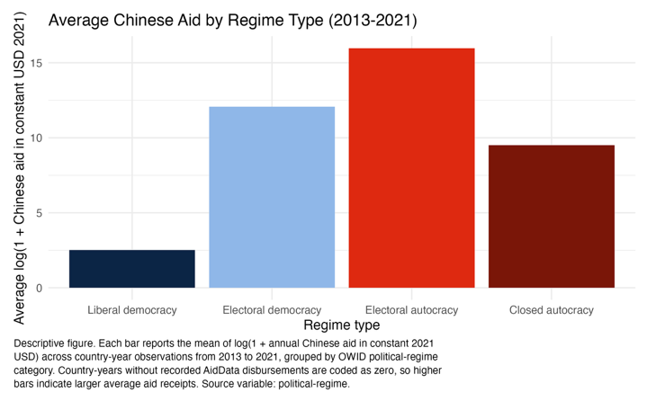 | 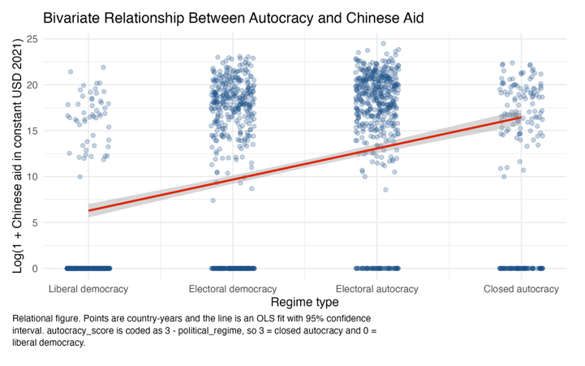

Chinese Aid and Regime Type (Country-Level Cross-Section)
 | Dependent variable:
 | Log(1 + mean annual Chinese aid in constant USD 2021)
 | Bivariate | Controls | Controls, positive-aid only
 | (1) | (2) | (3)
Autocracy score | 4.186*** | 0.948 | 1.083***
 | (0.769) | (1.171) | (0.397)
Log GDP per capita |  | -2.591*** | 0.812***
 |  | (0.960) | (0.276)
Corruption Perceptions Index |  | -0.207*** | -0.009
 |  | (0.061) | (0.026)
Extreme poverty share |  | -0.111** | 0.022
 |  | (0.046) | (0.013)
Gini index |  | 29.888*** | 1.008
 |  | (8.620) | (3.314)
Constant | 7.642*** | 35.808*** | 9.717***
 | (1.165) | (9.093) | (2.533)
Unit of analysis | Country | Country | Country
Years collapsed | 2013-2021 mean | 2013-2021 mean | 2013-2021 mean
Sample | All countries | All countries | Aid recipients only
Standard errors | HC1 | HC1 | HC1
Observations | 174 | 135 | 92
R2 | 0.202 | 0.594 | 0.165
Adjusted R2 | 0.197 | 0.578 | 0.117
Note: | *p<0.1; **p<0.05; ***p<0.01

Methodology and Findings:
Our empirical strategy uses cross-sectional OLS models with HC1 robust standard errors. The first model estimates the raw country-level association between autocracy and mean annual Chinese aid. The second adds controls for GDP per capita, corruption perceptions, extreme poverty, and the Gini index. The third re-estimates the controlled model only among countries that received positive Chinese aid. In the bivariate model, autocracy is positively and statistically significantly associated with aid. In the full-sample controlled model, the autocracy coefficient falls to 0.948 and is not statistically significant. However, in the positive-aid-only model, the autocracy coefficient is 1.083 and statistically significant at the 1 percent level, implying that a one-point increase in autocracy score is associated with roughly 2.95 times higher mean annual aid among aid recipients, holding other controls constant. Taken together, the findings suggest that regime type is not a robust predictor of Chinese aid across all countries, but it may matter conditional on already being selected into the pool of aid recipients.

Limitations and Conclusion:
Some limitations remain. Collapsing the data to country averages sacrifices within-country and year-to-year variation, so the design cannot identify how changes in regime type within a country affect aid over time. The full controls model also loses observations because several covariates are missing for some countries, reducing the sample from 174 to 135 countries. In addition, diagnostic checks indicate some influential country cases, so the substantive conclusions should be interpreted cautiously. Overall, the cross-sectional evidence does not show a stable relationship between autocracy and Chinese aid across the full sample, but it does indicate that among countries receiving Chinese aid, more autocratic regimes tend to receive larger average amounts.

